Benjamin Ngo

Instructor: James Morgan

T/TH 1:30PM – 2:45PM

CS185C

**--- Project** ---

**Name**: Volcanic Nutrition

**Demonstrate-able function:**

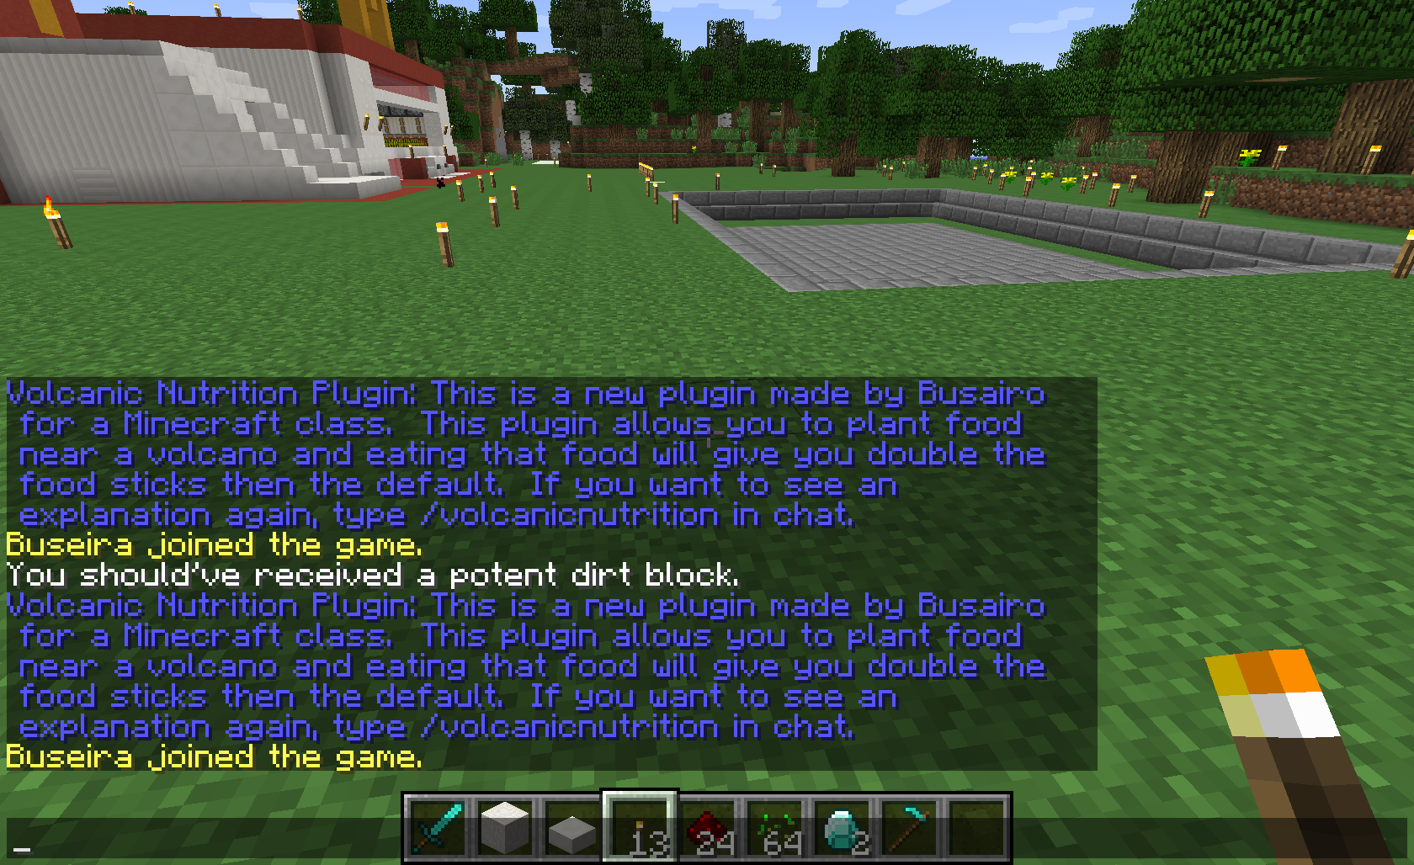

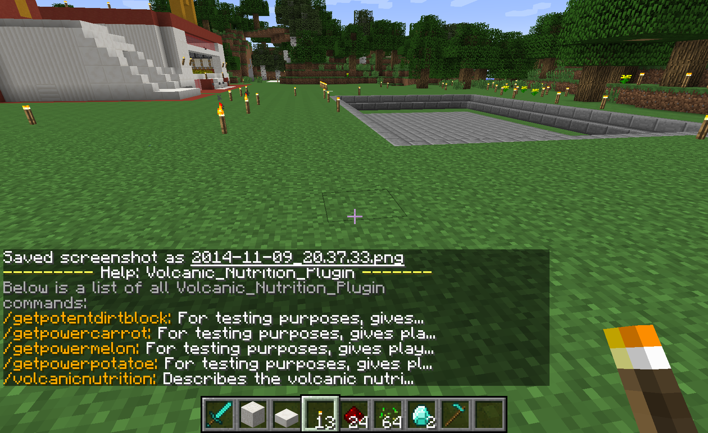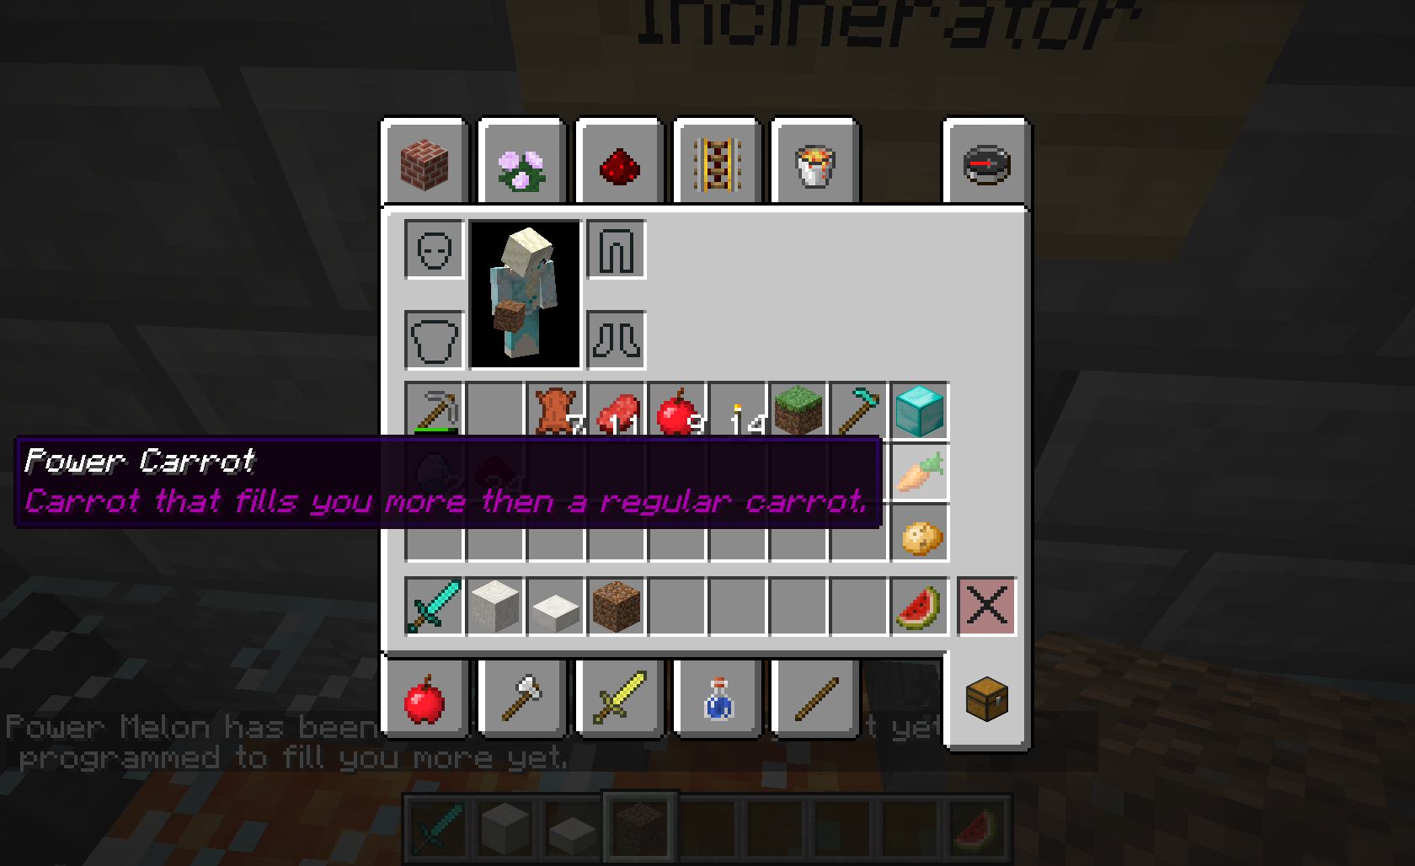

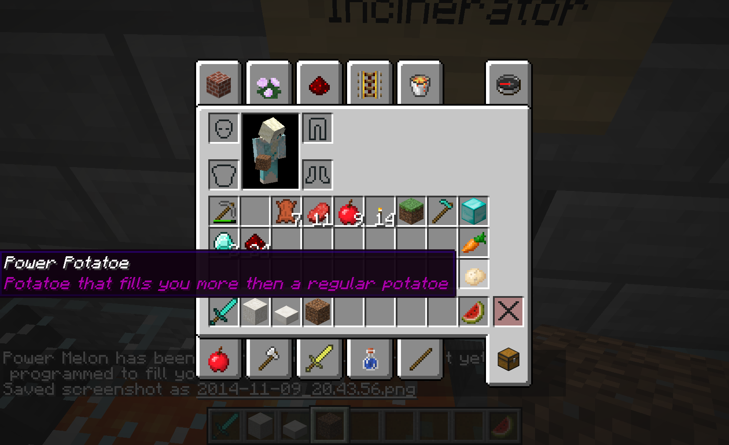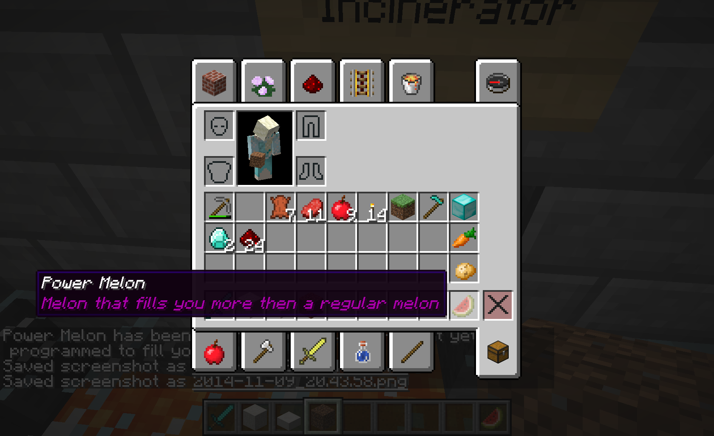

**GitHub Link:** <https://github.com/darkeclipse8/Volcanic-Nutrition.git>  
All my java files are in the src folder.

**Private Link**: Put this JAR file into a 1.7.9 bukkit server as that is what I programmed it for.  
<https://www.dropbox.com/s/23yr3dct5ebnach/VolcanicNutrition-0.0.1-SNAPSHOT.jar?dl=0>

**--- Documentation ---**

**How To Use**: This is a bukkit plugin. You need to make sure you have a bukkit server running, a 1.7.9 server. If you don’t know how to make a bukkit server, a simple google should suffice you. Then you can simply just take .jar file put it into your plugins folder for the bukkit server and off it goes.

When you are in your server. Search for the new Volcano biome that should be created in the final version as the current doesn’t have it yet. Grab some of the dirt or simply just start making a farm and grow the foods. A regular seed should do. After the vegetables are done growing, farm it and eat up. Satiety levels of the vegetables have been doubled.

**--- Testing ---**

**Roadmap To Finish**: Simply put, by the **end of November** I should have the biome, and everything else needed to make the mod work done**. Final testing will begin in December** and most likely end before due date and shouldn’t take more than a day or two to test max.

**Testing Protocol**: I simply just need my or a 1.7.9 server at home to test. I’ve been playing it with my cousin and we’ve built a lot of stuff. So testing this won’t be too hard. We just simply need to make a farm near the volcano biome I plan to make with my custom dirt blocks and grow the power vegetable seeds there and hope that what comes up are the power vegetables I programmed. And this can also be done in a large group, with the class, or just myself it doesn’t matter, the main purpose is to just test if planting the seeds of the power vegetables work.

**--- Groups ---**

**Team Member Roles and Responsibilities**:

I (Ben) am the only person working on this plugin. And my responsibilities are to research how to create my own biome, create a volcano, code a new kind of dirt, and the grow-able and editable plants of Minecraft. Then lastly put all this together into the final project.

**Group Member Evaluations**: There will be no evaluations for any group members as I am going solo on this project.